**Ohm's Law**

**Lab 1**

ECE 1101 Lab, Section 6

Date: Thursday August 29th, 2019

Kyler Martinez, Daniel Tan

Equipment Used In The Experiment:

* Lab-Volt Power Supply
  + Make/Model: 1224 AC/Dual DC Power Supply
  + Serial Number: N/A
* Keysight 4 ½ Digital Display Multimeter
  + Make/Model: U3401A
  + Serial Number: MY56150032
* John Fluke Multimeter
  + Serial Number: 56708

Materials Used In The Experiment:

* Breadboard
* 1kΩ Resistor
* 3.3kΩ Resistor
* 6.8kΩ Resistor
* 10 Ω Resistor

Objective:

The objective of the experiment was to validate the relationship shown in Ohm's law, V=IR. After validating Ohm's law, students must validate that VI = V2/R = I2R and then drive a resistor to its failing point.

Background Theory:

The theory is Ohm's law which states that between voltage, resistance, and current, there’s the relationship V= IR, where R is resistance, I is current, and V is the voltage. Another theory used in the lab is that power, VI , = V2/R=I2R with R= resistance, I is current, and V is the voltage.

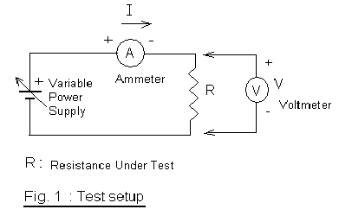

Procedure:

To begin the experiment, we set up the breadboard in compliance with figure 1. We had to connect the voltmeter and ammeter to the breadboard and record the current through a resistor and voltage drop for the resistor as we increased the voltage from 0 to 10 in increments of 2.

Data:

Table 1: Resistor Plate Vs. Measured Values

|  |  |  |
| --- | --- | --- |
| Plate Value | Measured Value | % Error |
| 1 kΩ | .9965 kΩ | -0.350% |
| 3.3 kΩ | 3.2851 kΩ | -0.452% |
| 6.8 kΩ | 6.722 kΩ | -1.147% |
| 10 Ω | 10.13 Ω | 1.300% |

Table 2: Measured Voltage & Current & Calculated Power

|  |  |  |  |  |  |  |
| --- | --- | --- | --- | --- | --- | --- |
| V in Volts | 0 | 2 | 4 | 6 | 8 | 10 |
| I of 1 kΩ in mA | 0 | 2.01680 | 4.02590 | 6.02400 | 8.04100 | 10.05400 |
| I of 3.3 kΩ in mA | 0 | 0.61550 | 1.22170 | 1.83010 | 2.44000 | 3.05110 |
| I of 6.8 kΩ in mA | 0 | 0.29610 | 0.59740 | 0.89470 | 1.19350 | 1.49390 |
| P=IV for 1 kΩ in W | 0 | 0.00403 | 0.01610 | 0.03614 | 0.06433 | 0.10054 |
| P=I*I*R for 1 kΩ in W | 0 | 0.00405 | 0.01620 | 0.03616 | 0.06443 | 0.10073 |
| P=V*V/R for 1 kΩ in W | 0 | 0.00401 | 0.01610 | 0.03613 | 0.06422 | 0.10035 |
| P=IV for 3.3 kΩ in W | 0 | 0.00123 | 0.00489 | 0.01098 | 0.01952 | 0.03051 |
| P=I*I*R for 3.3 kΩ in W | 0 | 0.00125 | 0.00490 | 0.01100 | 0.01956 | 0.03058 |
| P=V*V/R for 3.3 kΩ in W | 0 | 0.00122 | 0.00487 | 0.01096 | 0.01948 | 0.03044 |
| P=IV for 6.8 kΩ in W | 0 | 0.00059 | 0.00238 | 0.00537 | 0.00955 | 0.01494 |
| P=I*I*R for 6.8 kΩ in W | 0 | 0.00059 | 0.00240 | 0.00538 | 0.00958 | 0.01500 |
| P=V*V/R for 6.8 kΩ in W | 0 | 0.00060 | 0.00238 | 0.00536 | 0.00952 | 0.01488 |

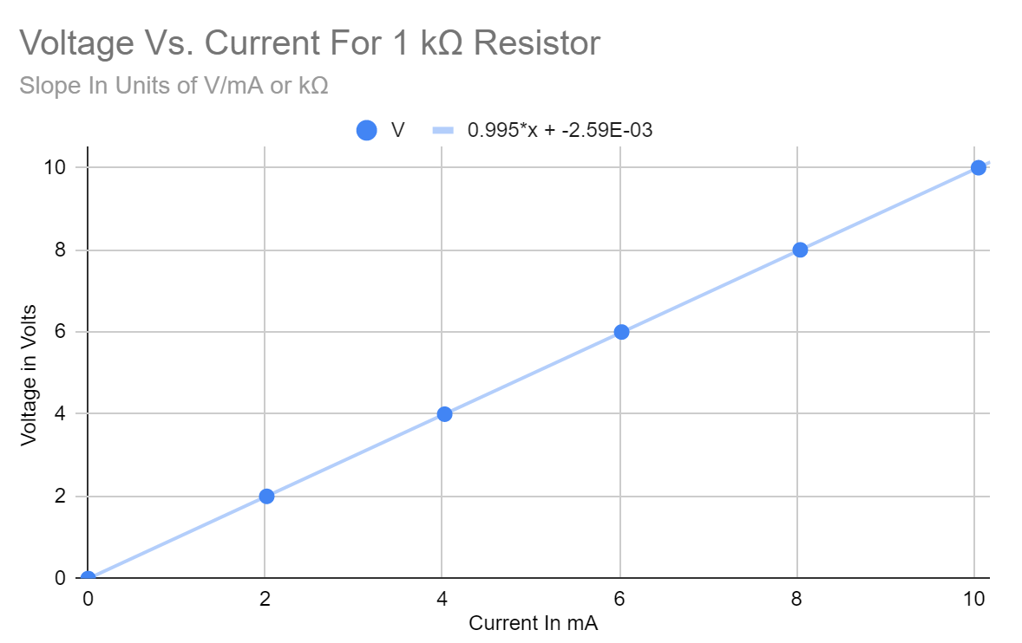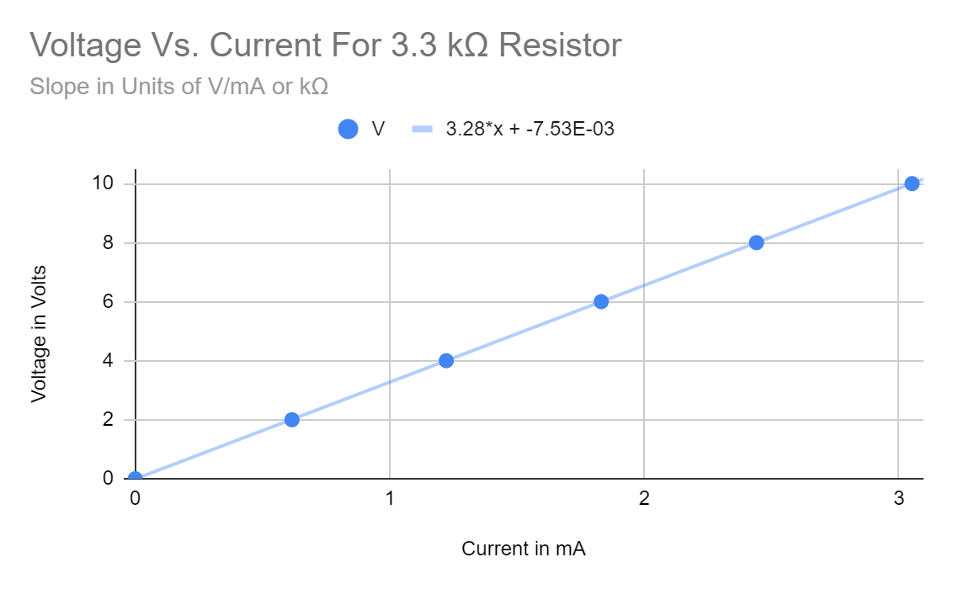

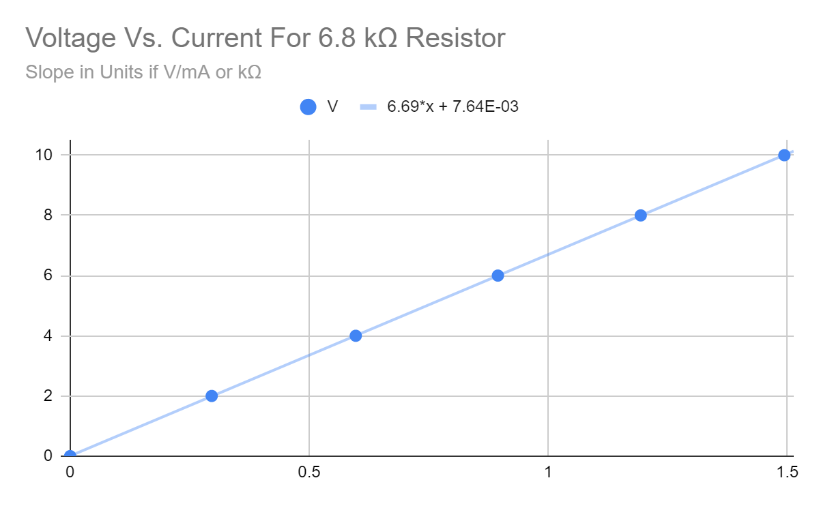

Table 3: R Vs. the Value Inferred from Slope

|  |  |  |
| --- | --- | --- |
| Measured Value | Value from Slope | % Error |
| .9965 kΩ | 0.995 kΩ | -0.15% |
| 3.2851 kΩ | 3.28 kΩ | -0.16% |
| 6.722 kΩ | 6.69 kΩ | -0.48% |

Conclusion:

After plotting each of the graphs, we noticed that when making a line of best fit, it went through most of the data points and the slopes of the lines was roughly equal to the resistance of the resistor used when gathering the data. This demonstrates the linear relationship between voltage and current with the resistance of a resistor acting as a constant of proportionality. However we did have an error from our measured resistance and the value inferred from the slope with all values from the slope all being under the true value while having less than .5% error under the true value. Having a small percent error shows the accuracy in our lab but isn’t perfect.

Some theories regarding the cause of error include having incorrect voltage and when we record oru readings. When choosing equipment we choose the voltmeter to be the Fluke multimeter which allowed for one two decimal precision and human precision makes it difficult to manually set the voltage of the power to exactly a whole number voltage exactly each time a new voltage is set. When we read measurements on the multimeters, the numbers typically fluctuate and depending on when we recorded the data the number could fluctuate higher or lower than the recorded value and cause a different reading.

**Ohm’s Law Post Lab**

**Lab 1**

Results:

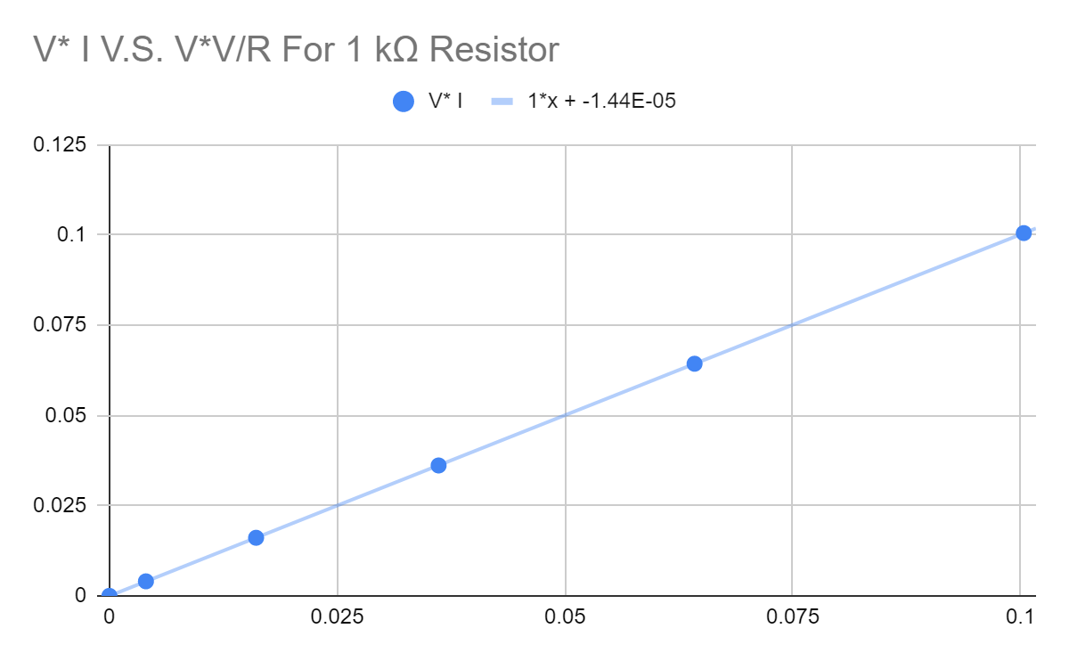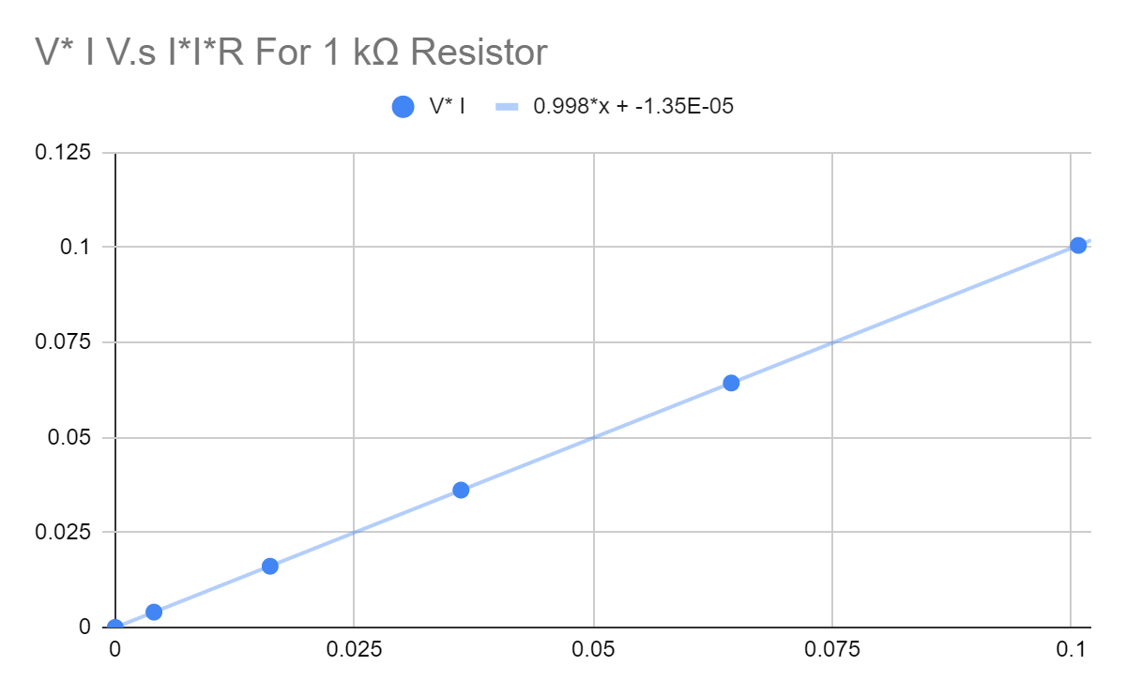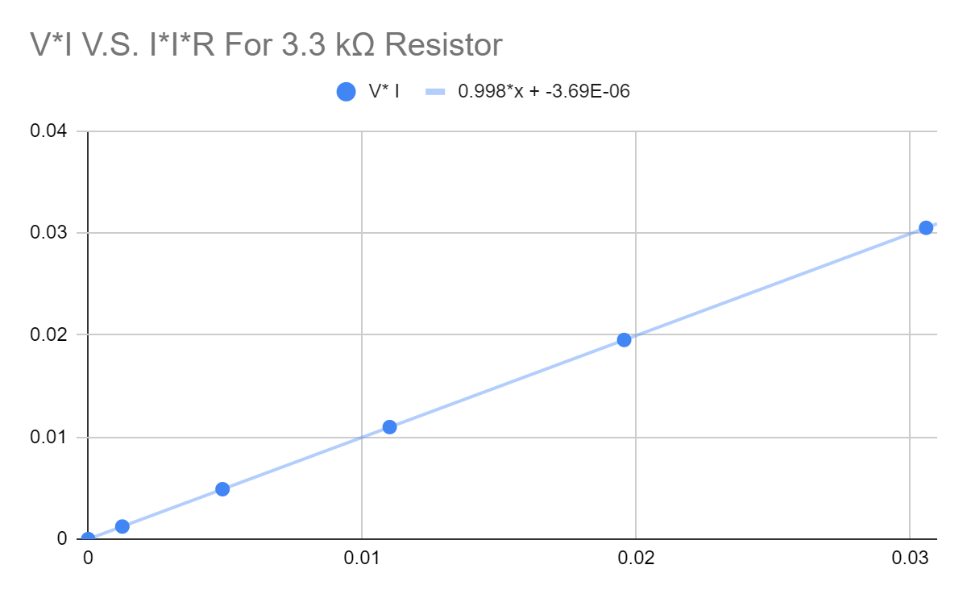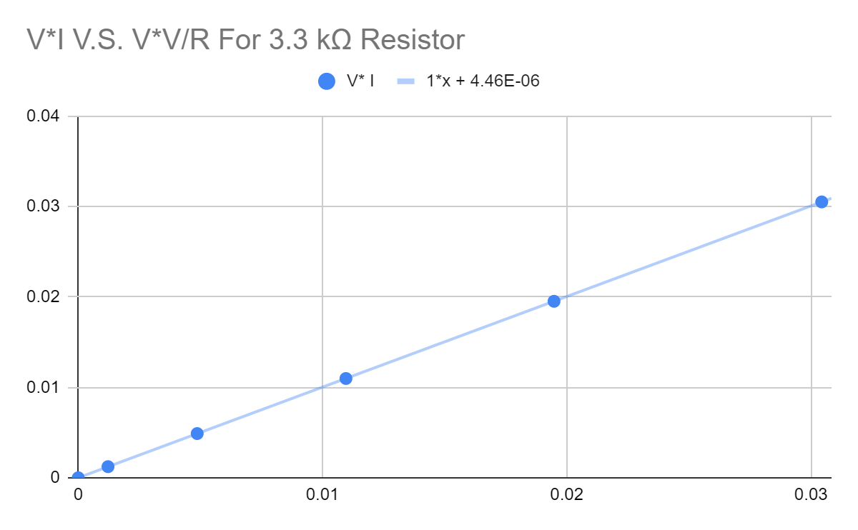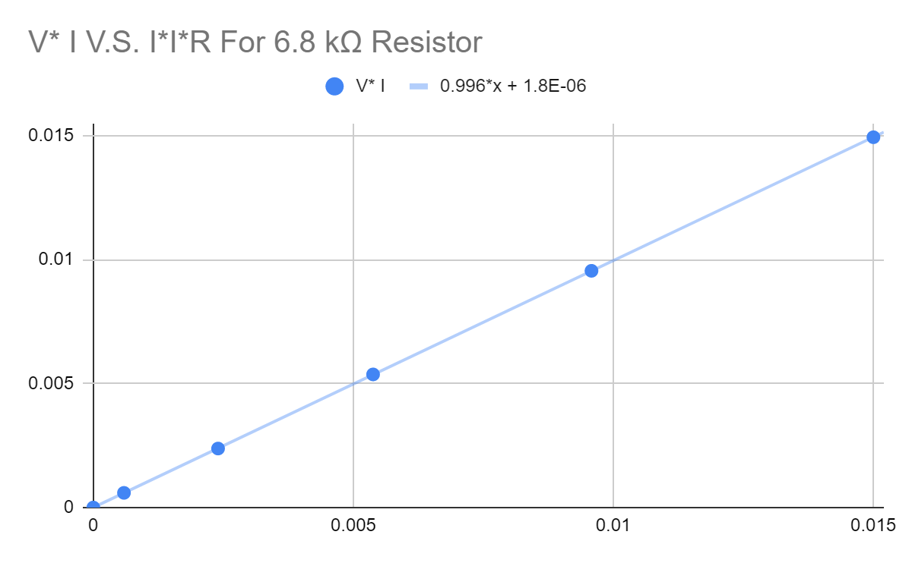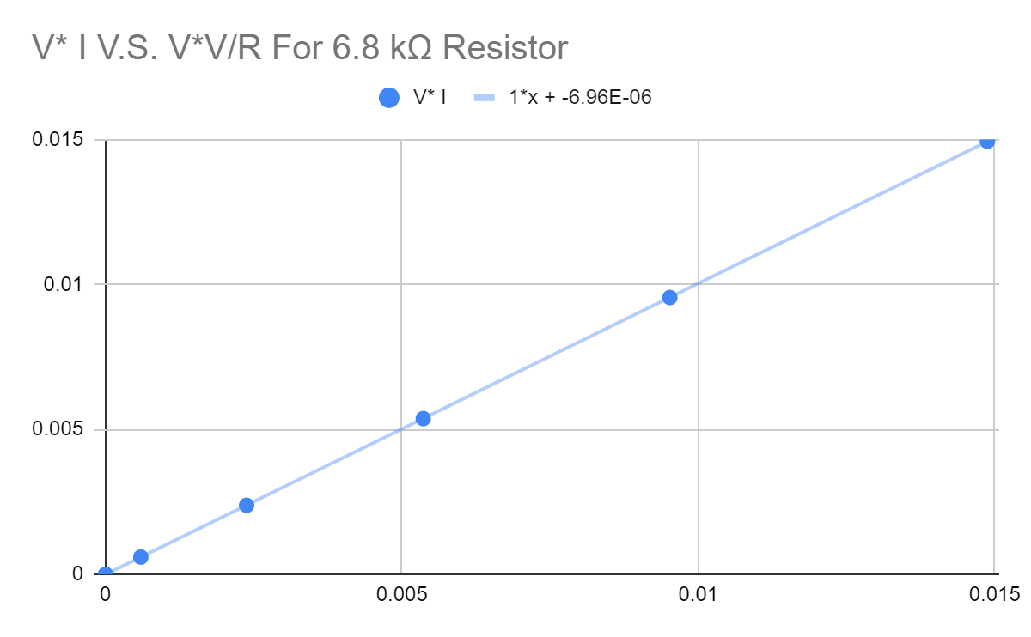

Conclusion:

While performing the calculations of power for each of the resistors and creating the graphs for them, we noticed that the line of best fit went through all data points and the slopes of each of the graphs were either 1 or were less than .01 from 1. Due to the slope representing the divisions of VI and the other equations for power, a slope of 1 would signify that both of the equations would be equal. By having slopes at 1 or close to one, the experiment showcases that VI=I2R=V2/R. The error we encountered ranges from about 0% to -.4%, this can be attributed to any errors caused by gathering measurements in gathering current, voltage, and the resistance of resistors. 

To test the power stress of the resistor we set up the breadboard as seen in figure 1 and increased the voltage of the power supply to about 2.5 V, which was calculated to be roughly the safe voltage of the resistor and we observed that the resistor was warm when we touched it. We then increased it to about 12.5 V, five times the safe value, when the resistor began to crackle and smoke and when it stopped smoking, we recorded 12.5 V as our failing voltage for the resistor. We then measured the resistance of the resistor after burning and read 1.152 Ω. This is a 88.48% reduction in resistance and shows that burning a resistor can damage it and reduce its resistance and this could potentially damage other components in the circuit with more current flowing through components. An error analysis couldn’t be performed for this portion of the lab, but it can be the result of stopping the burning of the resistor prematurely and adding too little voltage or too much and recording inappropriate values.